**Amazon Sales Report Analysis**

|  |  |  |
| --- | --- | --- |
| **S.NO:** | **TABLE OF CONTENTS** | **PAGE.NO** |
|  | Introduction | 2 |
|  | Data Overview | 2 |
|  | Sales Overview | 3 |
|  | Product Analysis | 4 |
|  | Fulfilment Analysis | 5 |
|  | Customer Segmentation | 6 |
|  | Geographical Analysis | 7 |
|  | Business Insights | 8 |
|  | Conclusion | 8 |
|  | Appendix | 9 |

**1. INTRODUCTION**

The purpose of this analysis is to provide actionable insights from the Amazon sales data to support business decision-making. The key objectives of this analysis are:

* **Sales Overview**: Understand the overall sales performance, trends, and patterns over time.
* **Product Analysis**: Analyze the distribution of product categories, sizes, and quantities sold to identify popular products.
* **Fulfilment Analysis**: Investigate the fulfilment methods used and their effectiveness in delivering orders.
* **Customer Segmentation**: Segment customers based on their buying behaviour, location, and other relevant factors.
* **Geographical Analysis**: Explore the geographical distribution of sales, focusing on states and cities.
* **Business Insights**: Provide actionable insights and recommendations to optimize sales strategies, improve customer satisfaction, and enhance overall business performance.

**2.Data Overview**

The dataset contains information about sales transactions on Amazon, including details such as order ID, date, status, fulfilment method, sales channel, product category, size, quantity, amount, shipping details, and more.

**Basic Statistics**

* Number of records
* Number of unique products
* Number of unique customers

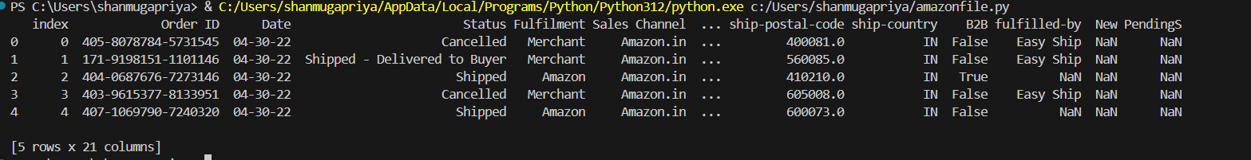**Figure 2.1**

**3.Sales Overview**

**Description**

Analyze the overall sales performance over time to identify trends, peaks, and patterns.

**Insights**

* Discuss any notable trends or patterns observed in sales over time.

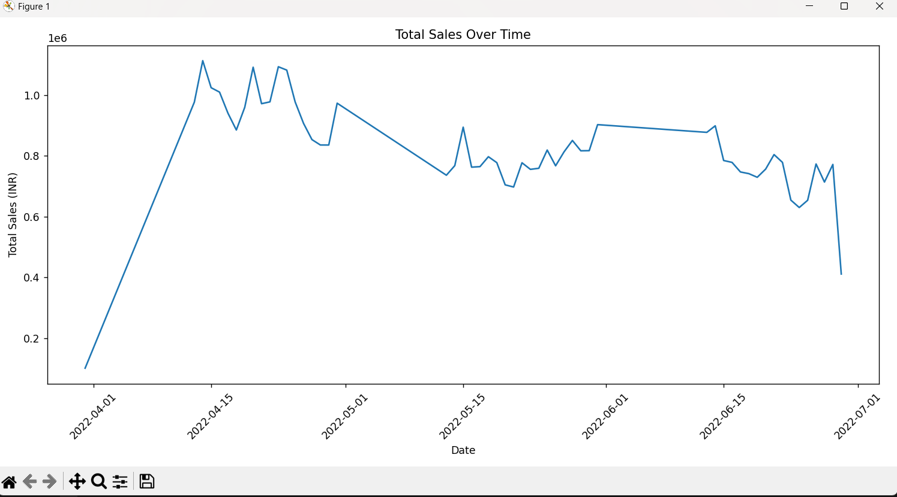

**Figure 3.1**

**4.Product Analysis**

**Description**

Analyze the distribution of product categories and sizes to identify popular products.

**Insights**

* Identify which product categories are most popular.
* Discuss the distribution of product sizes.
* 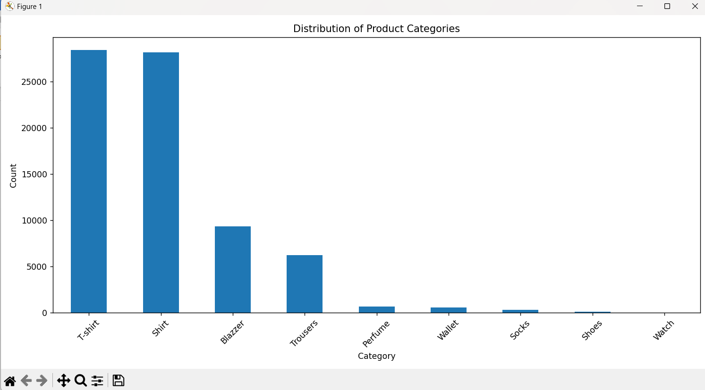

**Figure 4.1**

**5.Fulfillment Analysis**

**Description**

Investigate the fulfillment methods used and their effectiveness in delivering orders.

**Insights**

* Assess the effectiveness of different fulfillment methods.

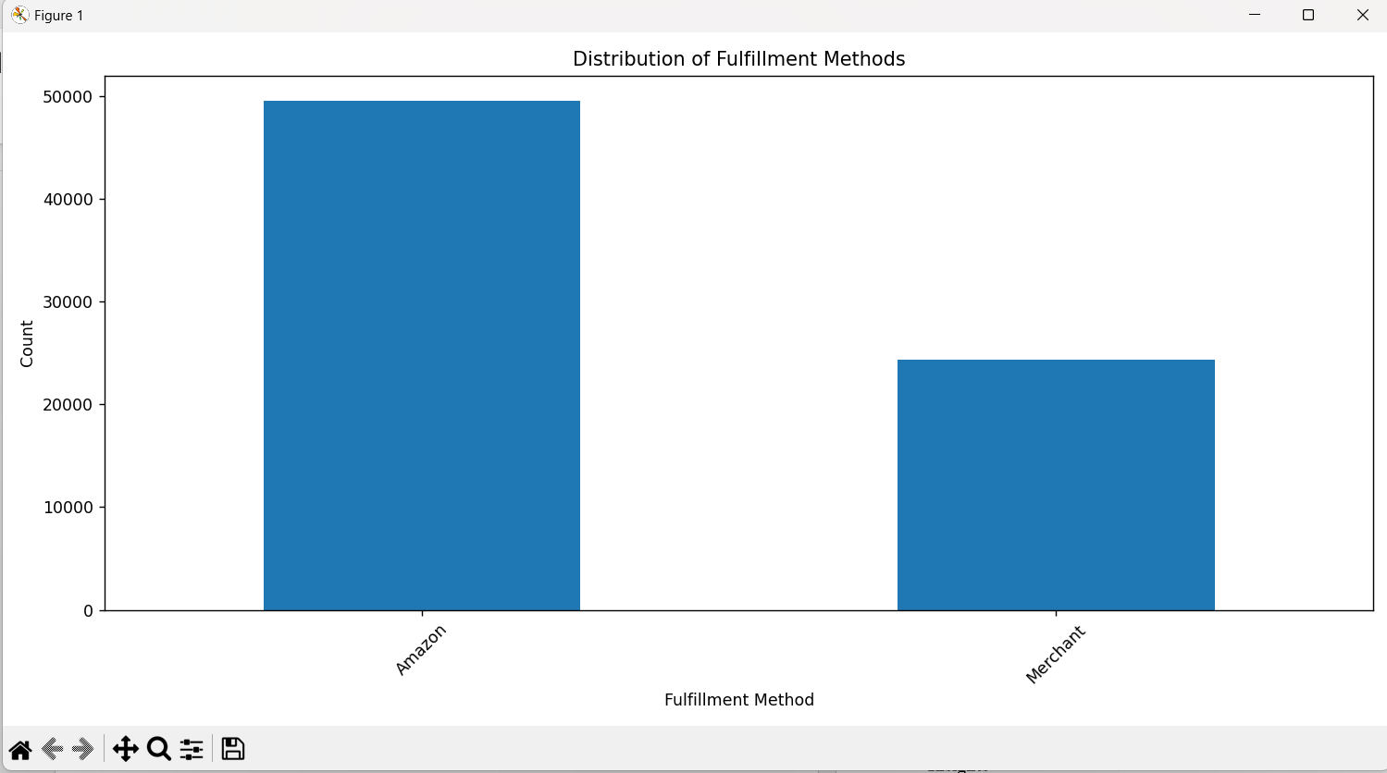

**Figure 5.1**

**6**.**Customer Segmentation**

**Description**

Segment customers based on their buying behavior and location.

**Insights**

* Identify top cities by sales.
* Discuss notable patterns in customer behavior.
* 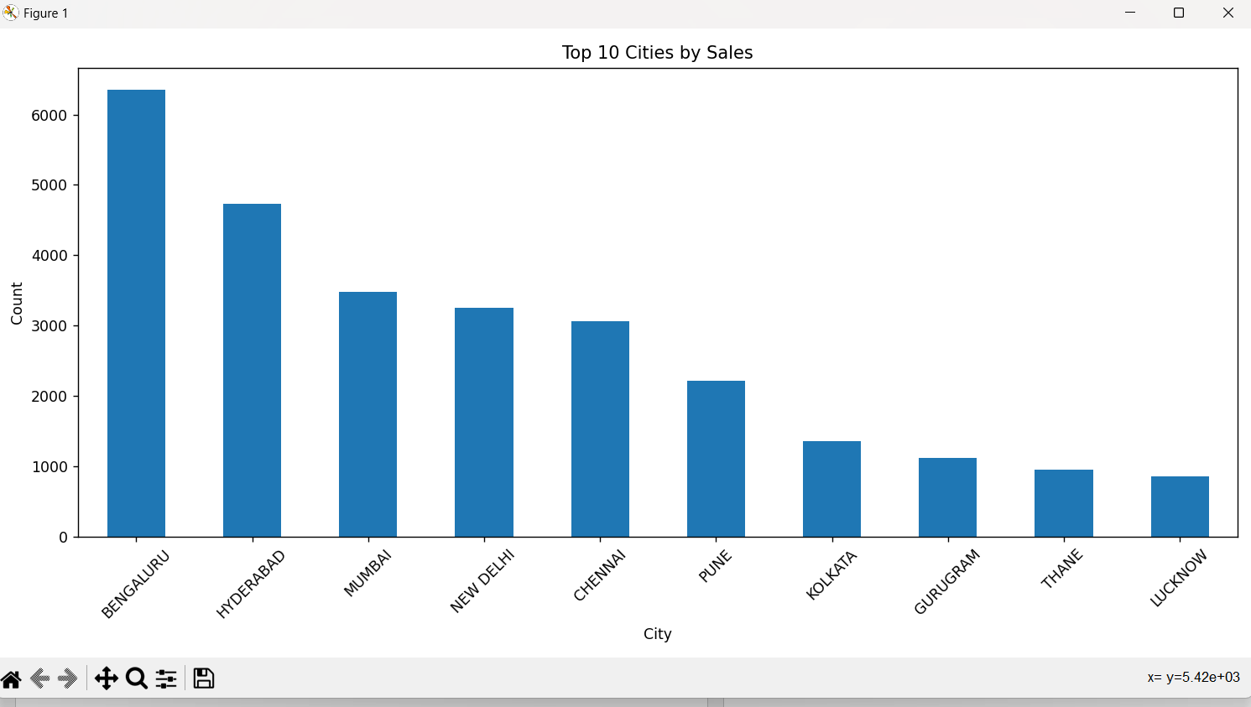

**Figure 6.1**

**7.Geographical Analysis**

**Description**

Explore the geographical distribution of sales by state.

**Insights**

* Discuss the sales distribution across different states.
* 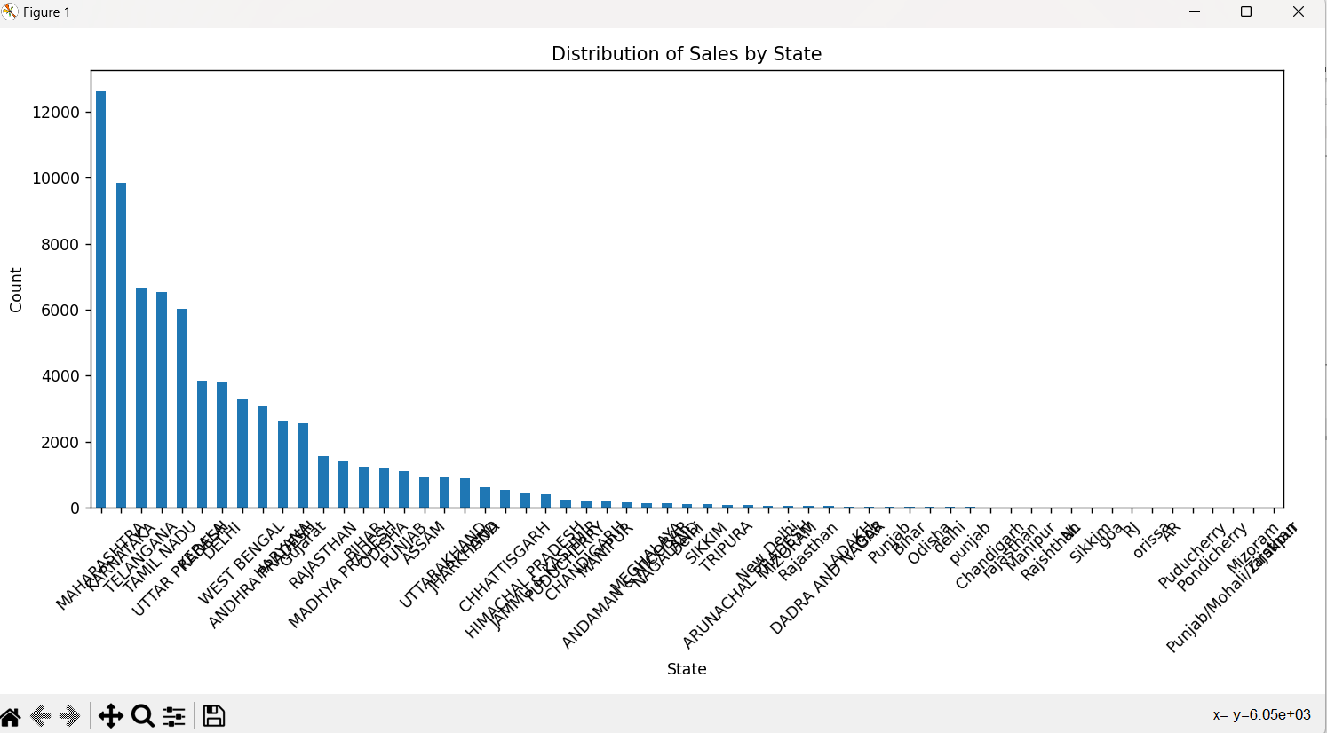 **Figure 7.1**

**8.Business Insights**

**Recommendations**

* **Optimize Inventory**: Ensure popular products are well-stocked.
* **Improve Fulfillment**: Enhance fulfillment methods to improve customer satisfaction.
* **Targeted Marketing**: Focus marketing efforts on top-performing cities and states.

**9.Conclusion**

The analysis of the Amazon sales report has provided valuable insights into various business aspects. We observed distinct sales trends over time, with clear seasonal peaks and troughs, which can help in demand forecasting and inventory management. Product popularity analysis revealed that certain categories are significantly more popular, guiding inventory decisions to ensure adequate stock levels. The evaluation of fulfilment methods highlighted preferences and effectiveness, suggesting areas for potential improvement. Customer segmentation and geographical analysis identified key locations driving sales, offering opportunities for targeted marketing strategies. Overall, these insights can help optimize sales strategies, enhance customer satisfaction, and improve business performance.

**10.Appendix**

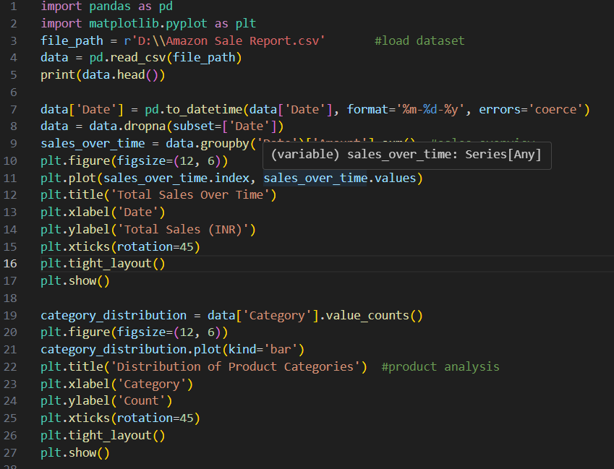

**Figure 10.1**